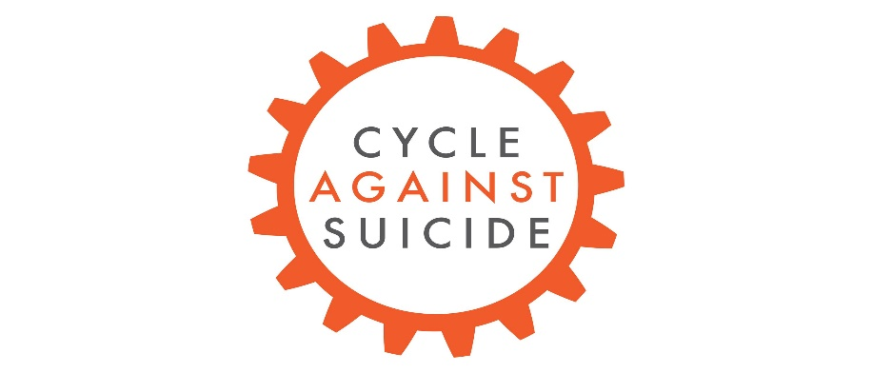

cycle against suicide will visit carrick on shannon

5th may 2018

BECOME A HOMESTAY
Central to the success of Cycle Against Suicide is the Homestay Programme. People throughout our island welcome participants of the event into their homes every year. Each homestay host provide cyclists with a warm meal, a chance to freshen up, and a bed for the night. Feedback from Homestay hosts indicates that this experience has been extremely rewarding, as it allows hosts to lend support in a very tangible way.

PLEASE CONTACT anne.mcgowan@cycleagainstsuicide.com
OR 087 224 9204 FOR MORE INFORMATION.

IT’S OK NOT TO FEEL OK; AND IT IS ABSOLUTELY OK TO ASK FOR HELP’

